Test Case: tc001_SPX_Dev5_Crear_Requisicion_Spot_Tipo_Cobro_CC
Step 1 - Enter username and password and click to button Enter : Credentials Entered
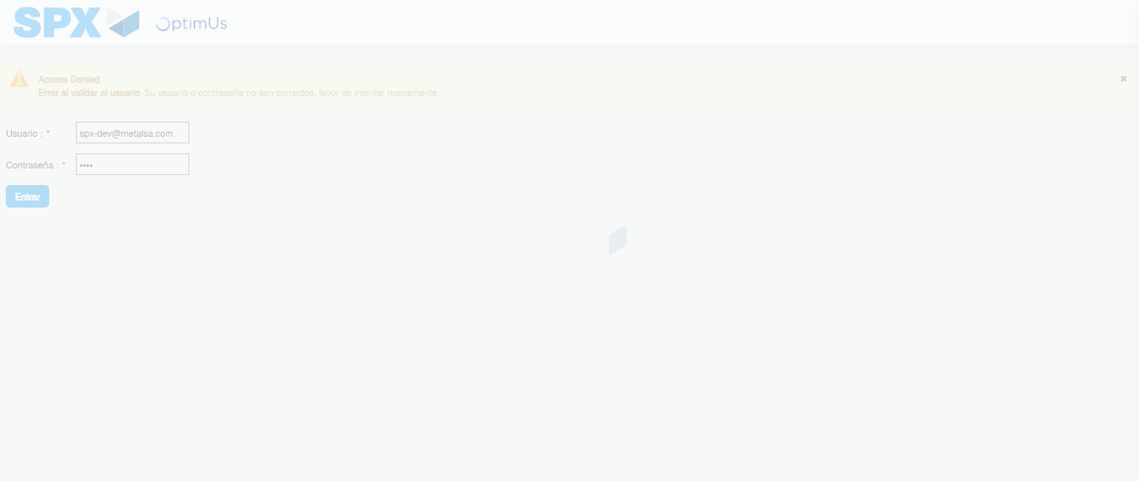Image file-name: QC_Testing-tc001_SPX_Dev5_Crear_Requisicion_Spot_Tipo_Cobro_CC-1784569383600

Step 2 - Select to UEN and Access to Spot Buy Requisitions : UEN Correctly selected and Correct access
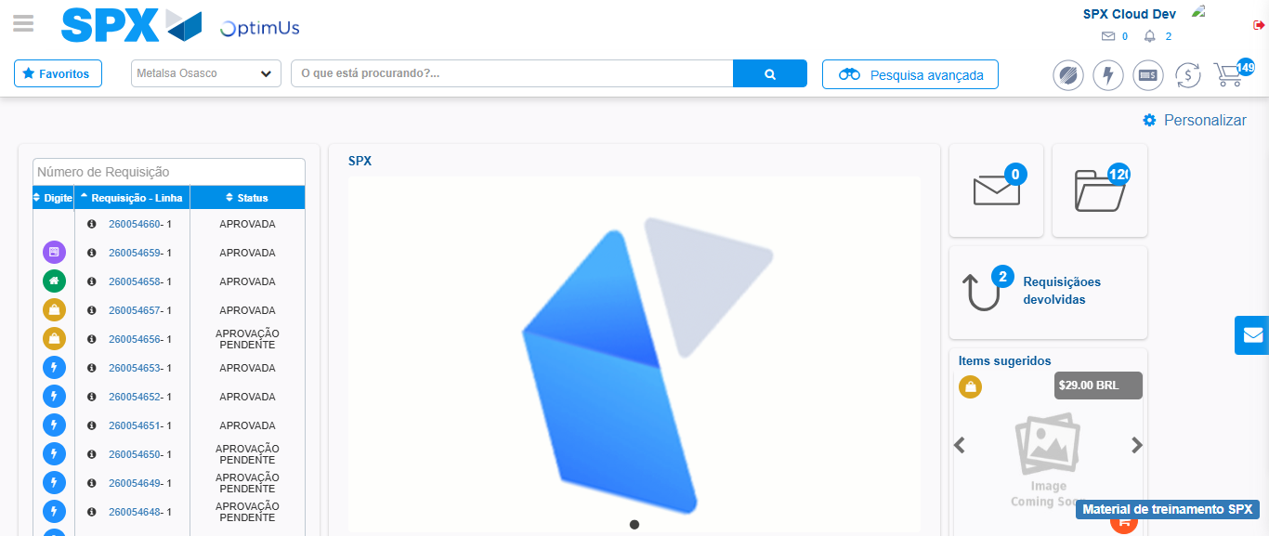Image file-name: QC_Testing-tc001_SPX_Dev5_Crear_Requisicion_Spot_Tipo_Cobro_CC-1784569461859

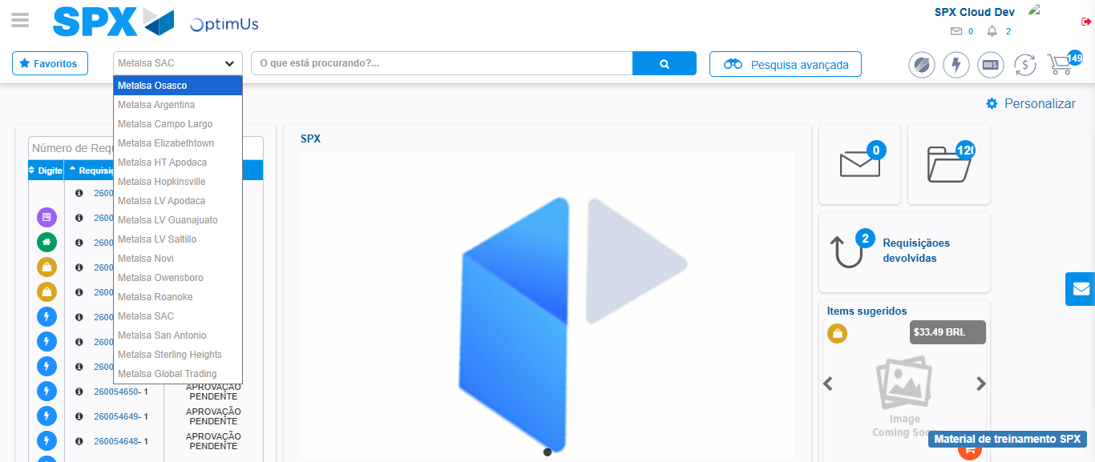Image file-name: QC_Testing-tc001_SPX_Dev5_Crear_Requisicion_Spot_Tipo_Cobro_CC-1784569464688

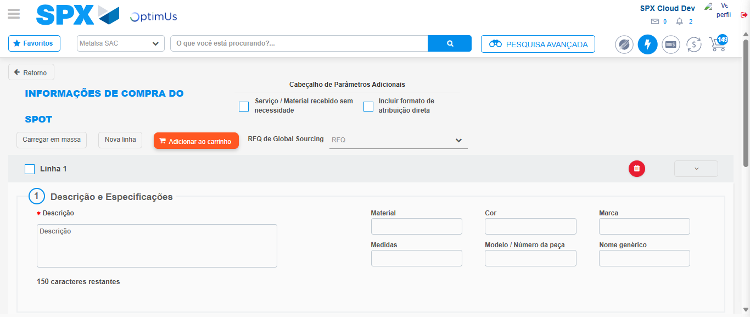Image file-name: QC_Testing-tc001_SPX_Dev5_Crear_Requisicion_Spot_Tipo_Cobro_CC-1784569496413

Step 3 - Data Capture Spot Buy Requisition : Data captured correctly
Image file-name: QC_Testing-tc001_SPX_Dev5_Crear_Requisicion_Spot_Tipo_Cobro_CC-1784569496697

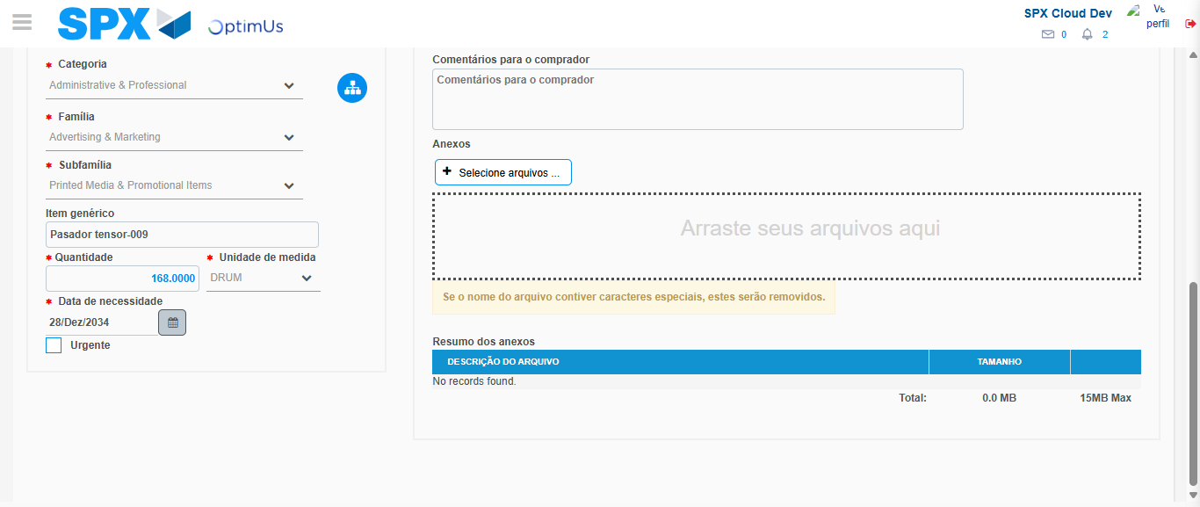Image file-name: QC_Testing-tc001_SPX_Dev5_Crear_Requisicion_Spot_Tipo_Cobro_CC-1784569511140

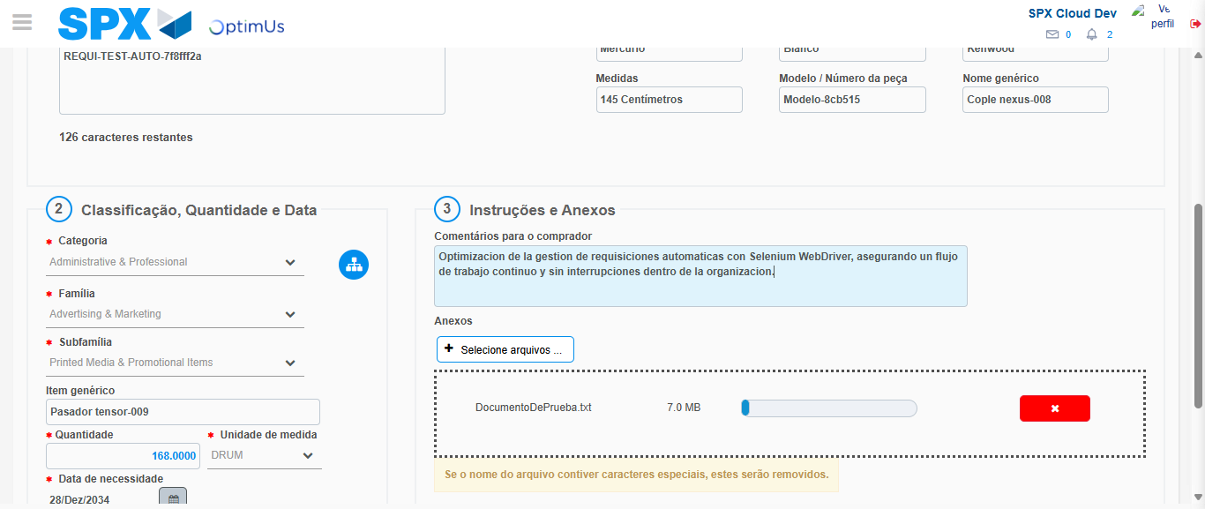Image file-name: QC_Testing-tc001_SPX_Dev5_Crear_Requisicion_Spot_Tipo_Cobro_CC-1784569512043

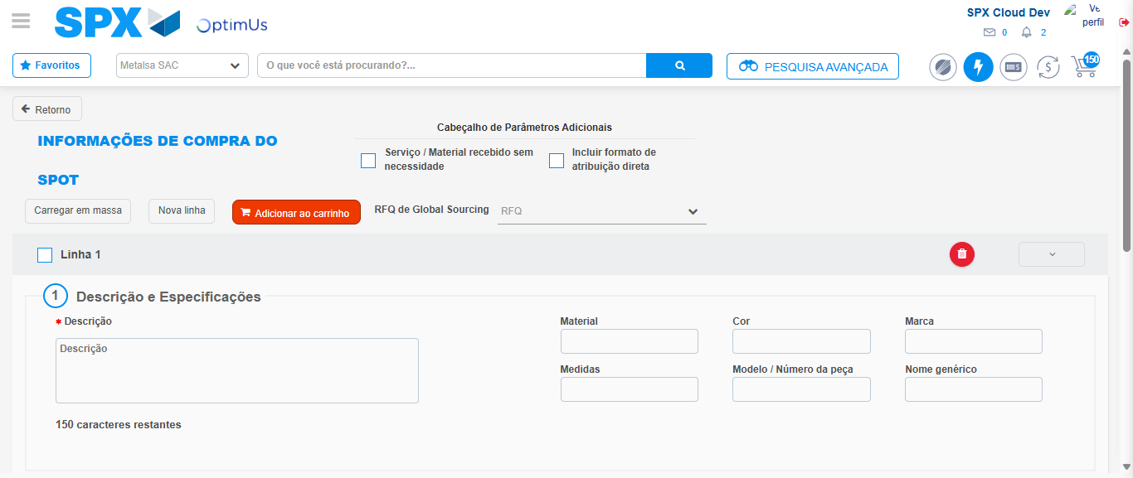Image file-name: QC_Testing-tc001_SPX_Dev5_Crear_Requisicion_Spot_Tipo_Cobro_CC-1784569528637

Step 7 - Return to Main Page SPX : Return to Main Page SPX
Image file-name: QC_Testing-tc001_SPX_Dev5_Crear_Requisicion_Spot_Tipo_Cobro_CC-1784569461859

Image file-name: QC_Testing-tc001_SPX_Dev5_Crear_Requisicion_Spot_Tipo_Cobro_CC-1784569464688

Image file-name: QC_Testing-tc001_SPX_Dev5_Crear_Requisicion_Spot_Tipo_Cobro_CC-1784569496413

Image file-name: QC_Testing-tc001_SPX_Dev5_Crear_Requisicion_Spot_Tipo_Cobro_CC-1784569530904

Image file-name: QC_Testing-tc001_SPX_Dev5_Crear_Requisicion_Spot_Tipo_Cobro_CC-1784569531112

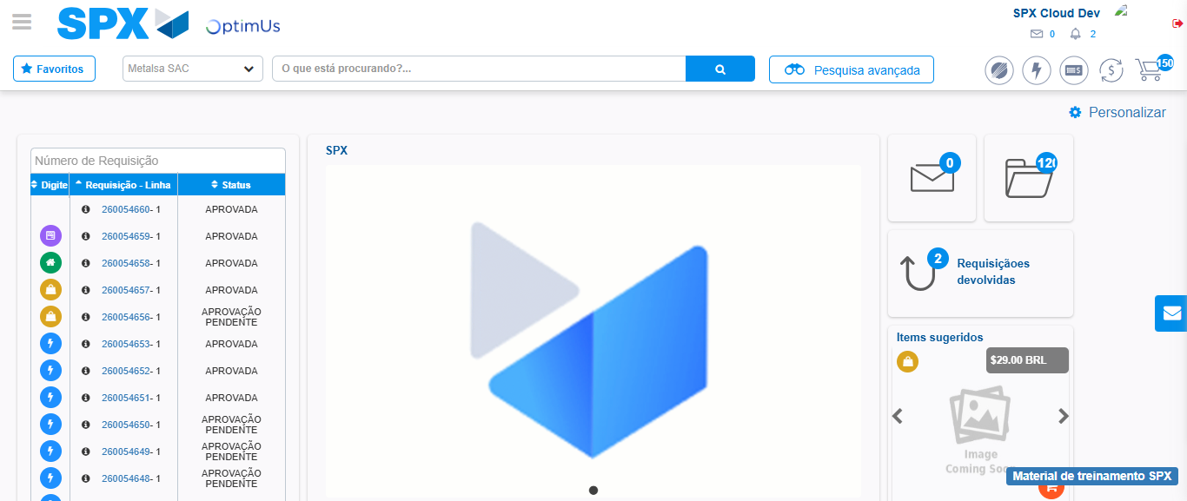Image file-name: QC_Testing-tc001_SPX_Dev5_Crear_Requisicion_Spot_Tipo_Cobro_CC-1784569552463

Step 8 - Log Out : Log Out SPX
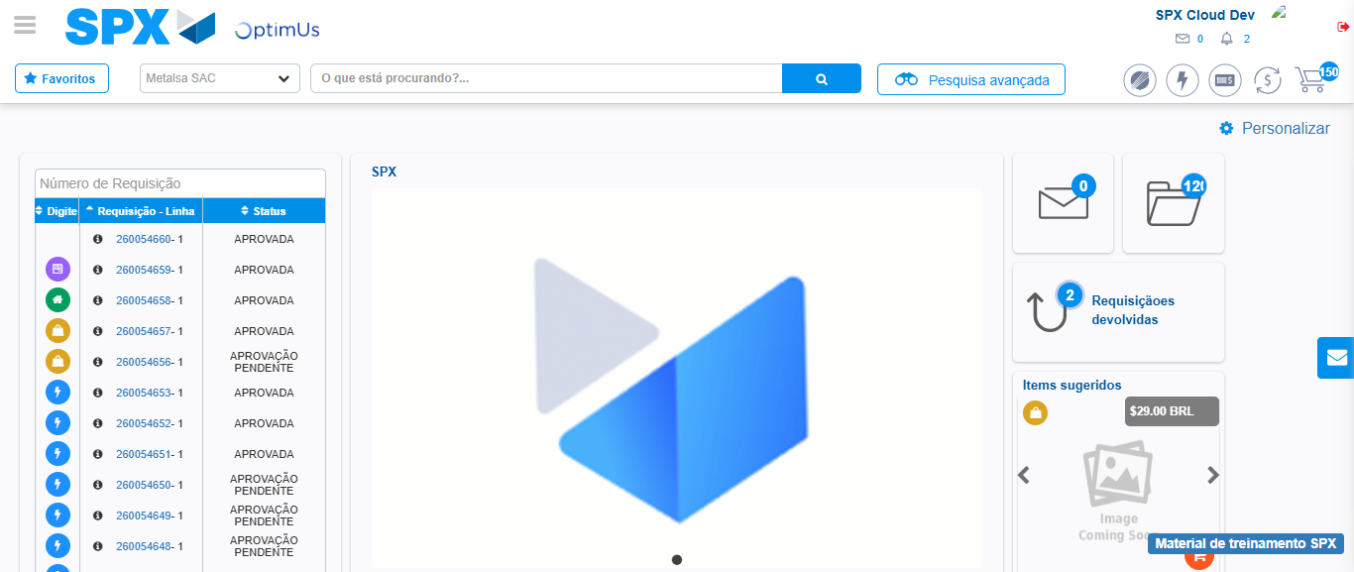Image file-name: QC_Testing-tc001_SPX_Dev5_Crear_Requisicion_Spot_Tipo_Cobro_CC-1784569552898

